Project ODIN
Optimized Data Infrastructure for NSE
Backtesting Engine

Manager Report | June 2026
StrykeX Strategy Builder | strykex.in/strategy-builder
Initial Scope: NIFTY + 5-Minute Timeframe
Confidential | StockWiz Technologies LLP | Internal Distribution Only
Executive Brief
StrykeX backtest requests for NIFTY 5-minute strategies currently timeout due to unbounded QuestDB scans, per-request indicator recomputation, and single-threaded Python execution. Project ODIN introduces a multi-tier data and compute acceleration layer — Redis, Parquet, Polars, and Numba — between the StrykeX Strategy Builder and QuestDB.

The StrykeX UI remains unchanged. Only the backtest backend is augmented. Target outcome: cold backtest response from 60+ second timeout to under 8 seconds; repeat requests under 500ms.

Recommended Action: Approve Phase 0 + Phase 1 immediately. No new infrastructure required. Production cutover at Phase 5 (Week 6).

Table of Contents

1. Executive Summary
StrykeX users building strategies on NIFTY 5-minute charts routinely encounter timeout errors and multi-minute wait times when running backtests. Root cause analysis identifies three compounding failures in the current path: (1) unbounded QuestDB scans that fetch years of data regardless of user-specified date ranges, (2) full indicator recomputation from scratch on every request, and (3) single-threaded Python loops for condition evaluation.

Project ODIN is a dedicated backtest data and compute acceleration service that sits between the existing StrykeX Strategy Builder and QuestDB. It introduces a four-layer stack — Redis hot cache, Parquet columnar store, nightly indicator precomputation, and a Numba JIT execution kernel — to serve the majority of backtest requests in under 10 seconds without touching QuestDB at runtime.

The StrykeX frontend and user experience remain completely unchanged. ODIN is a backend-only acceleration layer — no UI modifications are required in this project scope.

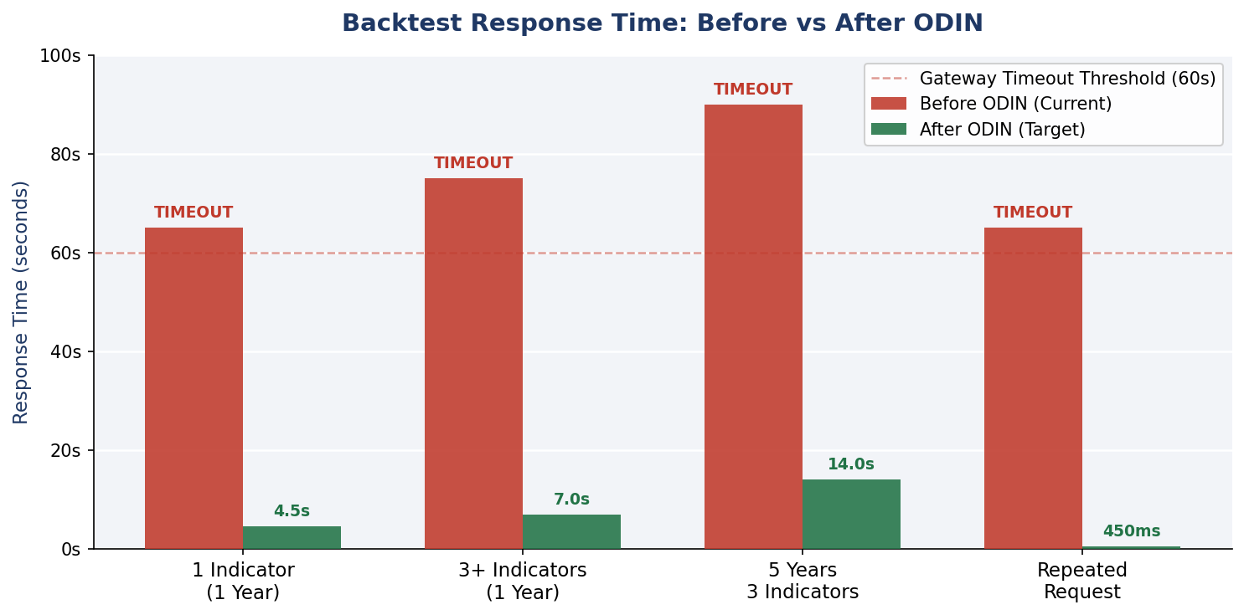
Figure 1: NIFTY 5m Backtest Response Time — Before vs After ODIN

2. Problem Statement
The StrykeX Strategy Builder guides users through a four-step flow to configure and run a backtest: (1) Strategy Overview — instrument, segment; (2) Strategy Setup — chart timeframe, spot/futures; (3) Entry & Exit Criteria — indicators and conditions; (4) Preview and Deployment — backtest execution.

2.1 Current Failure Modes
- Backend fetches full 5-year OHLC history from QuestDB on every request, regardless of user-specified date range
- Every indicator (RSI, EMA, MACD, ATR, Bollinger Bands) is recomputed from raw OHLC on every single backtest run
- Condition evaluation loop runs as single-threaded Python, iterating candle-by-candle
- HTTP gateway timeout threshold (typically 30–60 seconds) is hit before results return
- Second run of the identical strategy produces the same slow path — no caching layer exists today

2.2 Impact on Users
"Oops timeout error" — This is the error message StrykeX users see today on any strategy with 2+ indicators or a date range exceeding 6 months. The experience effectively blocks the core use case of the Strategy Builder.

3. Proposed Solution — ODIN Architecture
ODIN introduces a multi-tier acceleration layer. Each tier attacks a distinct bottleneck. The layers are ordered by speed — a hit at L1 (Redis) bypasses all slower tiers below. Only requests with no cached data reach QuestDB.

Layer | Technology | Purpose | When Bypassed
L1 — Hot Cache | Redis 7 | In-memory OHLC + indicator blobs (zstd compressed) | Every subsequent identical request
L2 — Column Store | Apache Parquet | Monthly columnar files per symbol/timeframe | Full cache hit at L1
L3 — Source | QuestDB (existing) | Ground truth for all market data — never removed | Always checked on gap only
L4 — Engine | Polars + Numba JIT | Vectorized indicator compute + condition evaluation | N/A — always executes on request
Batch | Nightly ETL (11PM IST) | Exports NIFTY 5m + precomputes Tier A indicators offline | Runs off-peak; never on request path

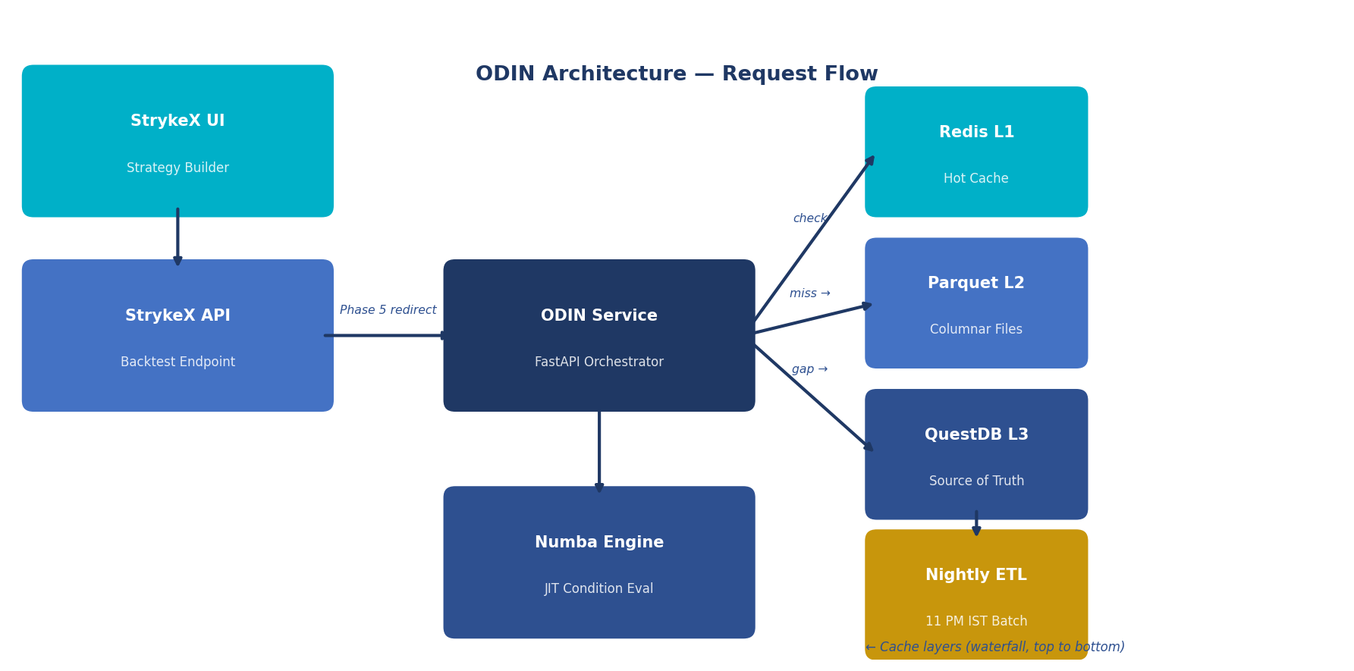
Figure 2: ODIN System Architecture — Request Flow Diagram

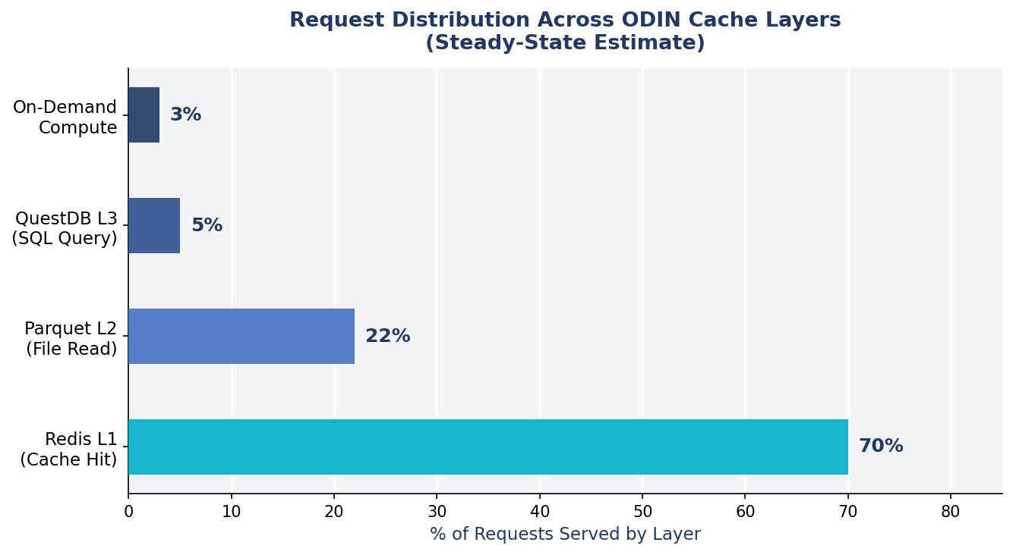
Figure 3: Steady-State Request Distribution Across Cache Layers

4. StrykeX UI → ODIN Parameter Mapping
ODIN exposes a single endpoint: POST /v1/backtest. The existing StrykeX backtest API forwards requests to ODIN unchanged in Phase 5 via a feature flag. The mapping between StrykeX UI fields and ODIN internal parameters is as follows:

StrykeX UI Field | ODIN Parameter | Notes
Instrument (NIFTY) | symbol=NIFTY | Phase 1 scope; BANKNIFTY added in Phase 6
Chart Time Frame (5 Minute) | timeframe=5m | Phase 1 scope; 1m / 15m / 1h added in Phase 6
Chart Selection (Spot) | series=spot | Affects QuestDB table and symbol key lookup
Entry conditions | entry_rules[] | Array of {indicator, operator, value} objects
Exit conditions | exit_rules[] | Supports indicator, time-based, and SL/target exits
Date range | start, end | Default: last 1 year; unbounded 5-year queries rejected

5. QuestDB Query Contract (Phase 0 — Immediate Win)
Before any new infrastructure is deployed, significant latency reduction is achievable by enforcing bounded, column-specific queries against QuestDB. The current path issues unbounded SELECT * queries across the full partitioned table — a preventable anti-pattern.

5.1 Required Query Pattern
Every ODIN query to QuestDB must conform to the following contract. Unbounded queries are rejected at the API layer before execution:

SELECT timestamp, open, high, low, close, volume
FROM ohlc_5m
WHERE symbol = 'NIFTY'
AND timestamp >= '2024-01-01T00:00:00.000000Z'
AND timestamp < '2025-01-01T00:00:00.000000Z'

5.2 Required Schema Checks
- Table must be partitioned by MONTH or DAY on the timestamp column
- Filters on symbol and timeframe must be in the WHERE clause — never filtered in Python post-fetch
- SELECT * is prohibited; only required columns are fetched
- Designated timestamp column must align with StrykeX 5-minute candle definitions

6. Parquet Storage Layout
Monthly Parquet files per symbol/timeframe replace hot SQL reads for the backtest data path. Apache Arrow (used by Polars) reads Parquet 10–30x faster than equivalent SQL for analytical column scans — the exact access pattern of backtesting.

data/parquet/
ohlc/
NIFTY/5m/
2021-01.parquet
2021-02.parquet
... (monthly partitions)
2026-06.parquet
indicators/
NIFTY/5m/
2024-01.parquet # rsi_14, ema_9, ema_20, atr_14, bb_upper, bb_lower, macd_*
catalog.json # manifest: min_ts, max_ts, available months per symbol/TF

Nightly ETL exports only NIFTY 5m initially. All other symbols and timeframes remain served by QuestDB until Phase 6. Estimated storage: 500 MB – 2 GB for full NIFTY 5m history.

7. Indicator Strategy
Indicator computation is the dominant compute cost for multi-indicator strategies. ODIN eliminates per-request indicator recomputation through a two-tier approach:

7.1 Tier A — Precompute Nightly (Standard Parameters)
Covers approximately 80% of user requests. Computed offline during the nightly ETL batch and stored in Parquet indicator files. Zero compute cost on the request path.
- Price fields: open, high, low, close, volume (from OHLC Parquet)
- Moving averages: EMA 9, EMA 20, EMA 50, EMA 200, SMA 20, SMA 50
- Momentum: RSI 14, MACD (12, 26, 9), Stochastic (14, 3, 3)
- Volatility: ATR 14, Bollinger Bands (20, 2)
- Additional StrykeX catalog indicators — full inventory required from product team

7.2 Tier B — On-Demand + Redis Cache (Custom Parameters)
Covers custom parameter combinations (e.g., RSI 21 instead of 14). Computed once with Polars on first request, then cached in Redis under a deterministic key. Subsequent requests with the same parameters return from Redis.
Cache key format: ind:NIFTY:5m:RSI:21:{start_hash}:{end_hash}

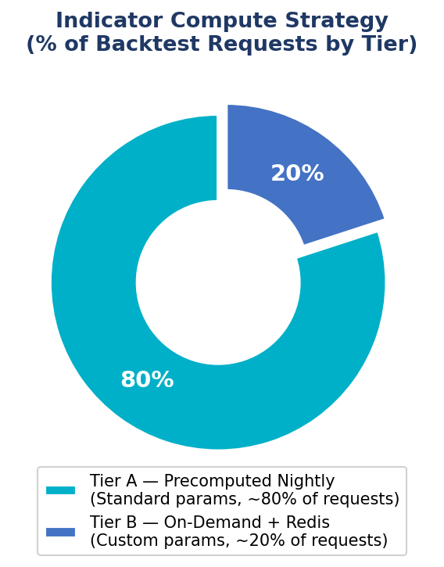
Figure 4: Indicator Compute Strategy — % of Requests by Tier

8. Phased Rollout Plan
ODIN is delivered across six production phases plus an initial baseline phase. Each phase has a single objective, a measurable exit criterion, and leaves the StrykeX UI unaffected.

Phase | Name | Timeline | Primary Goal
Phase 0 | Baseline & QuestDB Fixes | Week 1 | Immediate win — no new infra
Phase 1 | Parquet Tier | Week 2 | 10–30x faster analytical reads
Phase 2 | Redis Cache | Week 3 | Eliminates repeat-request latency
Phase 3 | Indicator Precompute | Week 4 | Addresses multi-indicator compute cost
Phase 4 | Fast Execution Engine | Week 5 | 10x+ condition loop speedup (Numba JIT)
Phase 5 | StrykeX Integration | Week 6 | Production cutover — end user impact
Phase 6 | Scale Beyond NIFTY 5m | Week 7+ | Full catalog: BANKNIFTY, 1m/15m/1h/Ray

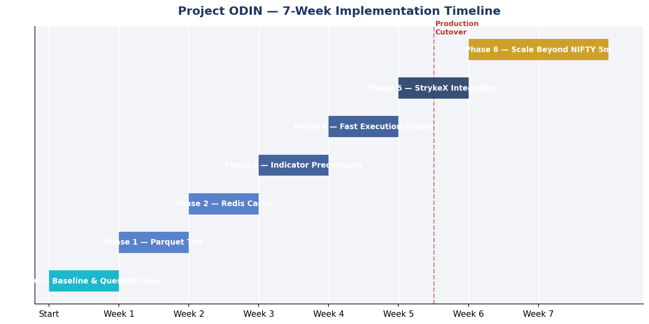
Figure 5: Project ODIN — 7-Week Implementation Timeline

Phase 0 — Baseline & QuestDB Fixes (Week 1)
Goal: Measure the exact latency breakdown; apply query contract for immediate gain.
- Profile current StrykeX backtest for NIFTY 5m: time in QuestDB fetch, indicator compute, condition loop, serialization
- Record p50/p95 latency and confirm gateway timeout threshold
- Apply QuestDB bounded query contract and confirm partition alignment
- Document StrykeX backtest API request/response JSON schema in docs/strykex-integration.md
Exit criteria: QuestDB queries for NIFTY 5m return in under 2 seconds for a 1-year range.

Phase 1 — Parquet Tier (Week 2)
Goal: Replace hot SQL reads with 10–30x faster Parquet column scans.
- Nightly job exports QuestDB NIFTY 5m to monthly Parquet files (initial backfill of full history)
- ODIN BacktestOrchestrator reads Parquet first; QuestDB queried only on date-range gap
- ParquetStore.read('NIFTY', '5m', start, end) via Polars pl.scan_parquet — lazy evaluation
Exit criteria: 1-year NIFTY 5m OHLC load under 500ms from Parquet.

Phase 2 — Redis Cache (Week 3)
Goal: Eliminate repeat-request cost; fix the "same strategy, second run" timeout pattern.
- OHLC cache key: ohlc:NIFTY:5m:{start}:{end} — Arrow IPC blob compressed with zstd
- Indicator cache key: ind:NIFTY:5m:{indicator}:{params_hash}:{start}:{end}
- TTL: 24 hours; affected keys invalidated after nightly ETL completion
- Expose /metrics endpoint: cache_hit_rate, p95_latency_by_tier, miss_reasons
Exit criteria: Identical NIFTY 5m backtest run twice — second run completes under 500ms total.

Phase 3 — Indicator Precompute (Week 4)
Goal: Eliminate the dominant per-request compute cost for multi-indicator strategies.
- Inventory all indicators exposed in StrykeX Entry & Exit Criteria dropdowns (required from product team)
- Precompute all Tier A indicators into data/parquet/indicators/NIFTY/5m/ during nightly ETL
- IndicatorResolver priority: precomputed Parquet → Redis on-demand cache → Polars compute
Exit criteria: Strategy with 3+ indicators completes under 5 seconds (cold) / under 1 second (warm cache).

Phase 4 — Fast Execution Engine (Week 5)
Goal: Replace the Python candle-by-candle loop with a compiled JIT kernel.
- Polars performs vectorized DataFrame prep and type normalization
- NumPy arrays passed to @numba.njit kernel for condition evaluation — no Python interpreter overhead
- Maps all StrykeX condition types: Equal, Greater Than, Less Than, Crosses Above, Crosses Below
- Supports Case 1 / Case 2 OR logic from the Strategy Builder entry block structure
- Returns same JSON response shape that StrykeX UI expects — trades, PnL, equity curve
Exit criteria: Condition evaluation loop 10x+ faster than the current Python implementation.

Phase 5 — StrykeX Integration (Week 6)
Goal: Route production traffic through ODIN; users stop seeing timeout errors.
- Option A (recommended): StrykeX backtest API routes to ODIN internally via feature flag USE_ODIN=true
- Option B: Parallel run — ODIN and legacy path execute concurrently; results validated before full cutover
- Async fallback: POST /v1/backtest/async → job ID → poll, for 5-year range requests only (if needed)
Do not resolve timeout issues by increasing the HTTP gateway timeout value. That approach masks the root cause and does not improve user experience. ODIN must deliver results within the existing SLA.
Exit criteria: NIFTY 5m backtest from StrykeX UI completes without timeout in staging with USE_ODIN=true.

Phase 6 — Scale Beyond NIFTY 5m (Week 7+)
Goal: Apply the proven ODIN pipeline to the full QuestDB instrument and timeframe catalog.
- Add BANKNIFTY → then all remaining NSE equity instruments
- Add 1m, 15m, 1h timeframes using the same Parquet + Redis + indicator pipeline
- Ray distributed execution for multi-instrument parallel backtests (when user selects multiple instruments in Step 1)
- Kafka integration only if live intraday data ingestion is added to the product roadmap
Exit criteria: Same latency targets achieved platform-wide for all symbol/timeframe combinations.

9. Timeout Fix Summary
Root Cause | ODIN Fix | Phase | Expected Gain
Full 5-year QuestDB scan | Date-bounded queries + monthly partition pruning | 0 | 2–5x immediate
Slow SQL columnar reads | Parquet L2 replaces SQL for backtest data loads | 1 | 10–30x
Repeat identical requests | Redis L1 cache with 24h TTL + ETL invalidation | 2 | 100x+ (warm)
Per-request indicator calc | Nightly precompute + on-demand Redis cache | 3 | 20–50x for Tier A
Python condition loop | Numba JIT @njit kernel on NumPy arrays | 4 | 10x+
Gateway timeout (60s) | All above combined → response under 10s | 5 | End-user fix

10. Success Metrics
The following KPIs define ODIN's success criteria. All measurements are against the NIFTY 5-minute backtest path, which is the primary user-facing bottleneck.

Metric | Current | ODIN Target | Improvement
1-Year, 1 Indicator | ~65s (TIMEOUT) | < 5s | 13x+
1-Year, 3+ Indicators | ~75s (TIMEOUT) | < 8s | 9x+
5-Year, 3 Indicators | ~90s (TIMEOUT) | < 15s | 6x+
Repeat Same Request | ~65s (TIMEOUT) | < 500ms | 130x+
UI Timeout Rate | High (>50%) | < 1% | >50x

Secondary KPI: Redis cache hit rate ≥ 70% in steady state (after the first week of production traffic). Measured via the /metrics endpoint exposed by ODIN.

11. Infrastructure Requirements
Component | Role | Status | Spec
QuestDB | Source of truth — all market data | Existing | All symbols/timeframes; ODIN exports NIFTY 5m first
Redis 7 | L1 hot cache for OHLC + indicators | New | 4–8 GB RAM; single node sufficient for Phase 1–5
Parquet on SSD | L2 analytical column store | New | ~500 MB–2 GB for NIFTY 5m full history
ODIN API | FastAPI backtest service | New | Single service; async handlers; structured logging
StrykeX Frontend | Strategy Builder UI | Unchanged | No UI modifications required in this scope
Nightly ETL | QuestDB → Parquet + indicator export | New | Cron job at 23:00 IST; runs off-peak; idempotent

Hadoop/HDFS is not appropriate at this data scale (5–50 GB). Apache Parquet and Apache Arrow are enterprise-grade big-data technologies that apply directly without a distributed cluster. This keeps operational overhead minimal.

12. Risks and Mitigations
Risk | Likelihood | Impact | Mitigation
Unknown QuestDB schema — table names, columns, partitions not yet documented | High | High | Phase 0 must document schema before any export job is written
StrykeX indicator name mismatch — UI names differ from function identifiers | Medium | Medium | Explicit registry.yaml mapping: UI name → compute function + default params
ODIN response shape mismatch — different JSON structure than current StrykeX API | Medium | High | Phase 0 captures full current API contract; ODIN adapter layer normalizes output
5m data is resampled, not native — ETL produces mismatched candles vs UI chart | Medium | High | Confirm with data team whether QuestDB stores native 5m or resamples from 1m
Cache staleness — user sees stale backtest results after market close | Low | Medium | Nightly ETL at 23:00 IST + Redis key invalidation on ETL completion
Redis memory exhaustion under high concurrency | Low | Medium | zstd compression on Arrow blobs; LRU eviction policy; monitor via /metrics

13. Repository Structure
Optimized Data Infrastructure For Backtesting Engine/
├── docs/
│ ├── architecture.md
│ ├── strykex-integration.md # API contract with existing backend
│ └── questdb-schema.md # table names, partitions, sample queries
├── data/
│ ├── raw/questdb-query-*.csv # offline dev only (gitignored)
│ └── parquet/ # generated output (gitignored)
├── services/
│ ├── odin-api/ # FastAPI: POST /v1/backtest endpoint
│ └── nightly-etl/ # QuestDB → Parquet + indicators (NIFTY 5m)
├── packages/
│ ├── odin-data/ # QuestDB, Parquet, Redis clients
│ ├── odin-indicators/ # registry.yaml + precompute + on-demand
│ └── odin-engine/ # ConditionEvaluator + Numba JIT kernel
├── infra/
│ └── docker-compose.yml # Redis + ODIN API (QuestDB external)
├── benchmarks/
│ ├── baseline_strykex.py # reproduces current slow path
│ └── odin_nifty_5m.py # NIFTY 5m before/after comparison
└── pyproject.toml

14. Open Items — Required Before Implementation
The following information must be provided by the StockWiz team before Phase 0 can begin:

- QuestDB connection details and exact table name for NIFTY 5m spot OHLC (host, port, database, TLS)
- Current StrykeX backtest API endpoint (URL, method) and full request/response JSON schema
- Full list of indicators exposed in Entry & Exit Criteria dropdowns (exact UI names)
- Default backtest date range applied when the user does not specify one explicitly
- HTTP timeout value configured on the gateway or load balancer (to define ODIN SLA)

Items 1 and 3 are hard blockers for Phase 0 and Phase 3 respectively. Items 2 and 5 are required before Phase 5 integration planning can begin.

15. Manager Demo Plan (End of Phase 5)
The following live demonstration will be recorded from the actual StrykeX UI to confirm production readiness:

- Open StrykeX Strategy Builder in browser
- Build strategy: NIFTY → 5 Minute → Spot → 2 entry indicators (e.g., RSI and EMA cross) → Run Backtest
- With USE_ODIN=false: demonstrate timeout or 60+ second wait (baseline recording)
- With USE_ODIN=true: demonstrate results appearing in under 5 seconds
- Run the identical strategy a second time — show sub-500ms response from Redis cache hit
- Present /metrics endpoint: cache_hit_rate, p95_latency_by_tier, QuestDB bypass rate
- Architecture walkthrough: QuestDB → Parquet → Redis → Numba Engine

16. Recommendation
Approve Phase 0 and Phase 1 to begin immediately. These two phases require no new infrastructure beyond QuestDB query contract enforcement and Parquet file export on existing hardware. Together they are expected to deliver the majority of total latency improvement — estimated 10–30x — before Redis caching or engine optimizations are applied.

Full production integration (Phase 5) is achievable within 6 weeks from Phase 0 kickoff. Phase 6 (full catalog scaling) can proceed incrementally without impacting NIFTY 5m production stability.

Recommendation | Action Required
Approve Phase 0 + Phase 1 | Confirm QuestDB schema details and begin baseline profiling this week
Provide Open Items 1–5 | Share QuestDB connection, API schema, indicator list, timeout value
Set Phase 5 demo date | Agree on Week 6 demo date for manager sign-off before production cutover

